DateGrade: An Application for Date Fruits Quality Grading using CNNs
By:
Mohammad Al-korj

Abstract
Date fruits are a perishable good presenting inherent challenges in quality and freshness assessment, making them difficult to evaluate in marketplaces. Consumers frequently lack the expertise or understanding required to assess the quality of the products they are buying, leading to uninformed decisions. This consumer naivety is often exploited by sellers using deceptive methods, such as inflating prices or substituting higher quality dates for lower quality ones. This project was motivated by the need to equip customers with a tool that provides real-time product recognition and quality assessment to alleviate these problems.
All efforts to classify date fruits by quality metrics have been focused on the agricultural pipeline. There is currently no user-centric solution for accurate date cultivar quality classification. The developed model, utilising the EfficientNet B3 CNN initialised with Noisy Student (NS) weights, demonstrates the feasibility of assessing date fruit quality from visual features alone. The model achieved 75.38% accuracy and a 71.09% F1-Score on the training set, confirming its success in learning the visual characteristics that distinguish quality grades. However, evaluation on the unseen test set showed evidence of overfitting, with performance dropping to 67.84% accuracy and a 64.84% F1-Score. The project also provides a promising foundation for automated quality control in agricultural supply chains.
Keywords:
Date fruits, quality assessment, mobile application, classification, defects, CNN

Table of Contents
Abstract 1
Table of Contents 2
Table of Figures 4
1. Introduction 5
2. Literature Review 5
2.1 Previous Work 5
2.1.1 Determining external quality metrics in date fruits 5
2.1.2 Date cultivar type classification 6
2.1.3 Date cultivar quality classification 7
2.1.4 Date cultivar defect classification 7
2.1.5 User-centric solutions 8
2.2 Research Gap 9
3. Methodology and Design 9
3.1 Dataset Acquisition 9
3.2 Controlled Variables 12
3.2.1 Model Selection Rationale 12
3.2.2 Candidate Models and Comparative Evaluation 13
3.2.3 General Preprocessing 14
3.2.4 Training Considerations 14
3.2.5 Deployment Considerations 14
4. Implementation 15
4.1 Materials and Methods 15
4.1.1 Dataset and Preprocessing 16
4.1.2 Model Architecture 17
4.1.3 Training Methodology 17
4.2 Experimental Setup 17
4.2.1 Implementation Details 17
4.2.2 Monitoring and Visualisation 18
4.3 Deployment 18
4.3.1 Model Evaluation 18
4.3.2 Prototype Deployment 18
5. Result and Evaluation 19
5.1 Results 19
5.2 Evaluation 21
5.2.1 Overfitting 21
5.2.2 Unusual Loss Behaviour 21
5.2.3. High Discrepancy in Cost/Time 21
5.2.4. Effectiveness of Early Stopping 21
6. Conclusion and Future Work 21
References 23

Table of Figures
Figure 1: classification of some date fruits in Grade ‘C’ 10
Figure 2: setup and top-level count (tree structure) of original and augmented dataset 11
Figure 3: sample of Gajar dates from augmented dataset 12
Figure 4: Project roadmap in phases 15
Figure 5: Validation Confusion Matrix after training 19
Figure 6: Validation Confusion Matrix after testing 20
Figure 7: GRAD-CAM heat map for predictions after training run 20
Figure 8: GRAD-CAM heat map for predictions after testing run 20

1. Introduction
We have all been at the buyer’s end of a trade in a store or market where we had no idea if the product we’re buying is worth the price. Many have also been to a seller wanting to buy a product knowing little, if anything, about it, therefore making uninformed purchasing decisions, as concluded from an experiment conducted by [1] which shows that consumers' imputation processes can be influenced by manipulating their prior information about a product category.
The ignorance of product information can be alleviated by an exploratory search online; however, this may be insufficient in some contexts. The buyer could be technologically inexperienced, making it challenging to navigate through the sea of information online [2]. Conversely, there may not be sufficient informative knowledge online regarding specific products, and this applies particularly to perishables due to varying freshness and limited product information, making them difficult to assess in online marketplaces [3], or markets of niche merchandise such as livestock as found in a study by Kansas State University [4].
Also, the heterogeneous nature of bulk products can lead to variability in quality and characteristics, which may cause consumers to question their purchasing decisions [5]. Oftentimes, when faced with time constraints, consumers may just prefer to rely on heuristic cues or tools to simplify their decision-making processes [6]. The issue could also be from the seller’s side, who may use deceptive selling methods that rely on customers’ naivety about the product to exploit them for their money [7].
The route to alleviate these problems is multifaceted, and the solution we propose focuses on the customer. We can equip them with a tool that recognises the product and provides a quality assessment. Since the primary user will be members of the public, it is imperative that this tool be accurate in its image detection and information, intuitive to use and easily accessible [8]. The rapid advancements in artificial intelligence (AI) have opened new possibilities for various industries, including product identification and analysis [9]. Traditional methods of product identification often rely on manual inspection, which can be time-consuming and prone to error [10].
Given the issues discussed above regarding the complexity of purchasing decisions involving the sellers and consumers, we selected date fruits as the focal product for our project. Date fruits are a perishable good and thus present inherent challenges in freshness and quality assessment.

2. Literature Review
We searched for previous works which implemented quality detection in either individual date fruits or whole bunches and had integrated this into a user interface. In the absence of such work, we sought out works that focus on those requirements separately: some works had implemented quality classification but had not yet developed the project to be usable for the general public in a user interface, or had done so for other perishables such as plants and herbs, while other works had implemented a functioning user interface to provide product classification and information, but did not consider quality classification.

2.1 Previous Work

2.1.1 Determining external quality metrics in date fruits
Fruit quality of date palm can be assessed using physical parameters such as fruit weight, size, dimensions, colour and fruit volume [12].
Oussama and Kherfi [13] state that ‘some varieties can easily be distinguished based on their visual aspect, whereas it is very difficult, for even a specialist, to distinguish between some other varieties. In such a case, the only thing that permits distinguishing them is their taste. In addition, there exists a noticeable difference between dates of the same variety, as they vary in terms of maturity level, hardness degree and shape.’
This was also confirmed by domain experts in markets dealing with date fruits for a living, who added that texture may also be used, but would need a trained eye. They also added that high quality dates should also not be covered by dirt and should be free from defects like skin separation, insect damage, sugar crystallisation, fungi or mould.

2.1.2 Date cultivar type classification
Much work has been done on date cultivar classification. In 2021, one team [14] employed logistic regression (LR) and artificial neural networks (ANN) to classify seven different types of date fruits based on 34 features, achieving an accuracy of 92.2% with ANN and improving it further to 92.8% by using a stacking model that combined both LR and ANN.
However, the classification accuracy depends on selecting appropriate features, which can be labour-intensive and less adaptive when applied to other types of products or fruits [15].
In 2022, another team [16] achieved 99% classification accuracy on eight different classes using MobileNetV2 architecture.
Then, in 2023 [17], Cordeiro et al. considered the classification of date fruits from a comparative perspective, with five learning algorithms: Support Vector Machines (SVM), Multi-Layer Perceptron (MLP), Naive Bayes (NB), K-Nearest Neighbor (KNN), and Logistic Model Trees (LMT). The algorithms were evaluated on three datasets. Two of these sets were derived from the original one by applying data balancing techniques. They observed a variation in the F-Measure of from 0.832 to 0.961, with the best F-measure obtained using stacking.
In November of the same year, Boumaraf et al. [18] classified two varieties of Algerian date fruit, each variety containing five classes for each grade (quality). Using chanelling techniques, they applied four model types, VGG16, InceptionV3, ResNet50 and Basic CNN, and VGG16 produced the best result of 90.4% validation accuracy.
In January 2024, Almutairi et al. [19] used 1735 images across 9 date varieties and three YOLO models to achieve the best results with the YOLOv8, a mean Recall of 0.99 % and Precision of 0.991%.
In April of that year, another team [20] developed a machine learning model utilising convolutional neural networks (CNNs). The model was trained on a dataset of 9,200 images representing six date varieties, achieving a remarkable classification accuracy of 98%.
In December of that year, Eskaf [21] used 900 total samples over eight date fruit types to test a multimodal approach, combining hyperspectral imaging, Visible–Near–Infrared (VisNIR) spectral sensors and traditional image analysis, and achieved scores of more than 90% on all evaluation metrics.
The latest effort in date fruit type classification was of Kourtiche et al. [22] in 2025, who employed feature map concatenation and layered stacking to achieve a result of 99.38% accuracy.
As is evident, in the few years since the proliferation of better CNN models, classification for date fruit types has improved significantly, with several teams independently achieving above 99% accuracy.

2.1.3 Date cultivar quality classification
By quality classification, we mean a system or model which predicts the grade of a fruit based on a scale of grades (e.g. excellent, good, satisfactory, poor, inedible, or, Grade 1, Grade 2, Grade 3).
There has been ample development in the quality classification of other produce, with particular attention across the board on the pre-sale pipeline, such as applications on farms and in factories [23], [24], [25], [26], [27].
As for quality classification of date fruits, the first work we found was published in 2019 [28], where they split their dataset of khalas dates into ‘good quality’ and ‘sugaring’ labels. By using the bag of features (BoF) classification algorithm along with the SVM classifier, they achieved 99% accuracy with 133 features and 50 clusters.
Then, in July 2023, Almomen et al. [29] replicated the work on Khalas dates and achieved 97% accuracy by focusing on general surface quality, splitting the dates under the labels ‘excellent surface quality’ and ‘poor surface quality’. They used the EfficientNetB0 model.
The same work by Boumaraf et al. [18] also considered quality classification, where they classified two varieties of Algerian date fruit, each variety containing five classes for each grade (quality). Using channelling techniques, they applied four model types, VGG16, InceptionV3, ResNet50 and Basic CNN, and VGG16 produced the best result of 90.4% validation accuracy.
The next prominent work attending to classification of dates based on external quality was in 2024 [30], where they compared the ability of a model to accurately predict the type based on the changes in external features depending on the duration of freezing. Using ‘Mejhoul’ and ‘Boufeggous’ dates, they proved that accuracy deteriorates the longer the date has been in frozen storage. However, they did not explicitly label the dates on a scale of quality grade.

2.1.4 Date cultivar defect classification
There has been ample research done on the effectiveness of CNNs to extract a more complex spatial relationship between pixels, improving performance in object recognition and texture analysis [31]. Therefore, Chuqurimarca et al. [32] reviewed and collated these efforts into the table below.
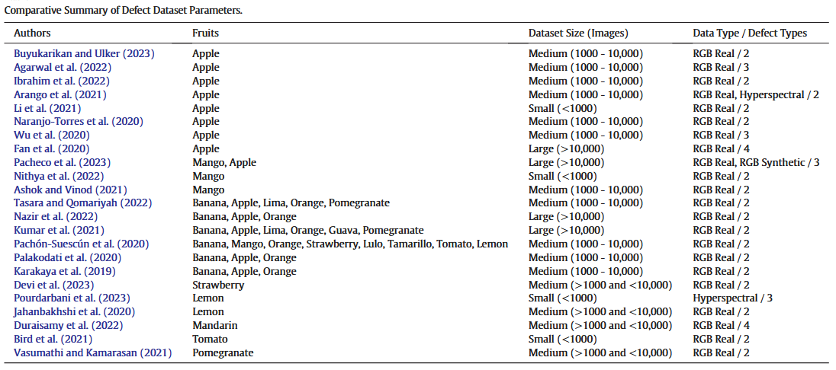
Figure 1: Comparative summary of Defect Dataset Parameters
They also produced a summary outlining which CNN model was used for each dataset.
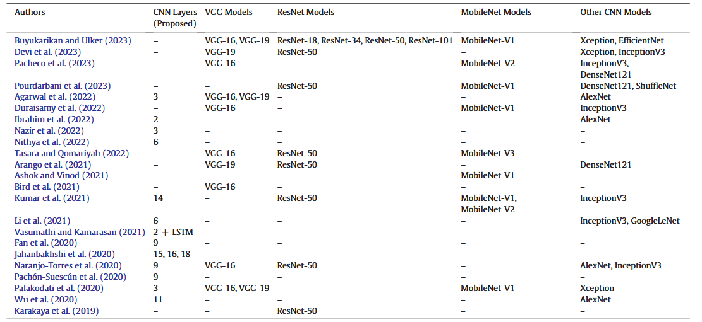
Figure 2: Comparative Summary of CNN Models for Fruit Defects
As for dates, the first available work [28] distinguished between good and sugared dates. The second work [18] classified dates based on an assigned label for its quality grade but did not focus on any specific defect.

2.1.5 User-centric solutions
We found a website [33] that classifies images of date fruits. The user must upload a JPEG image containing date fruit(s) and it returns its prediction as to the type of date. Upon testing this website, we found that its accuracy was subpar, as it failed to correctly classify many types of dates. Nothing was found that linked this website to an academic paper.

2.2 Research Gap
There is almost no research done on identifying specific defects in date fruits using CNN models, and the one work that did [18] did not focus on differentiating between different defects from one image; rather, they were restricted to the backdrop of comparing dates based on the labels ‘good’ and ‘sugared’.
The glaring gap was the non-existence of a user-centric solution for accurate date cultivar type, quality or defect classification. It is evident that there has been a preoccupation with the date fruit production pipeline before it reaches consumers. However, no matter how rigorously that chain is automated, it is bound to err, and if the user cannot confidently accept or reject a date fruit bunch based on other than arbitrary heuristics, they will remain vulnerable to open deception.
Our work bridges this gap by considering the consumer as the driver of the industry, which is why the resulting model was integrated into a mobile application, considering that it is the most apt device to provide this feature on-sight in the market.

3. Methodology and Design

3.1 Dataset Acquisition
After deliberation regarding the time constraint allocated to this project, we concluded that curating our own dataset is not feasible, and we would have to use a publicly shared dataset. This is due to the time and controlled conditions required to get date fruits to reach the state of defection, the resources and time for which we did not have.
When searching for publicly available datasets, we ensured to use all possible nomenclature under which such a dataset could fall under: ‘grade’, ‘quality grade’, ‘quality grading’, ‘grading’, ‘quality’, ‘external quality’, ‘characteristics’, ‘external characteristics’, ‘quality assessment’, ‘quality classification’. Though there are sundry works and models developed, the publicly available datasets on this topic are severely limited.
Dataset 1: a dataset of 18 classes (3 classes for each of 6 date fruit types [Ajwa, Glaxy, Medjool, Nabtat Ali, Sokari, Sugaey]), and the three classes labelled by quality grades ‘High’, ‘Medium’, ‘Low’. However, upon inspection, all images either have an unsupported file type or the files are corrupted, and the images aren’t displayed. [34]
Dataset 2: found on Roboflow, it contains 157 images of the Medjool type, featuring instances of varying qualities. [35]. This work, though standing in the premature niche of date quality assessment and accordingly commendable, falls short in many metrics, most starkly in the research approach. The dataset was used for quality classification, but the images weren’t labelled by quality grade, rather just by name.
Impressively, they also trained and tested a YOLOv8s model, incorporating object detection and grade classification, albeit at mAP@50, precision and recall scores between 40% and 50%. They did not determine which parameters/external quality characteristics contributed to their quality grade classification. This work is irreplicable, for there is no linked research document that explains the methodology adopted, neither in the data collection phase, nor in the model-building phase.
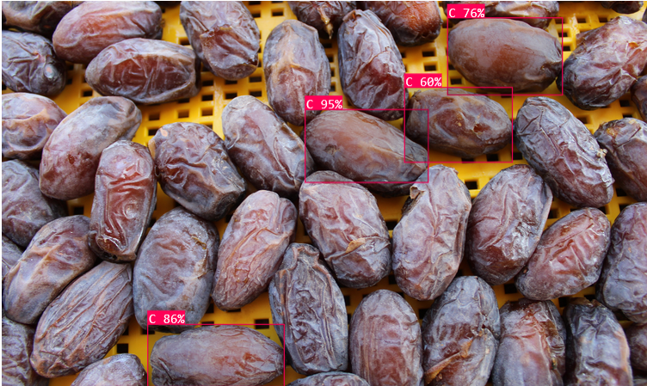
Figure 1: classification of some date fruits in Grade ‘C’
Dataset 3: the only functional dataset found was linked to a published research paper [36]. The dataset contains images of four date fruit varieties. It consists of 3004 pre-processed images of different classes and grades. Images have been sorted based on size as large, medium, and small. Additionally, it is graded based on the quality as grade 1, grade 2, and grade 3. This dataset is separated into eighteen different directories.
They also set up a consistent environment for image capture using the Huawei Y6s model JAT-L29 with a 13-megapixel camera and ring light. The ring light configuration was 26 cm outer diameter, a ring light having 3200K-5600K colour temperature with white light. Specifically, images were acquired through the top view with a 25.4 cm distance between the camera and the object. The acquired images were stored in their respective folders. The captured images were verified manually to remove blurred and poor-quality images [36]. They then augmented the classes that had less images, reaching a total of 19229 images in the same 18 classes. The replicability and rigorousness of the data collection and structuring process allowed us to use this dataset for our model.

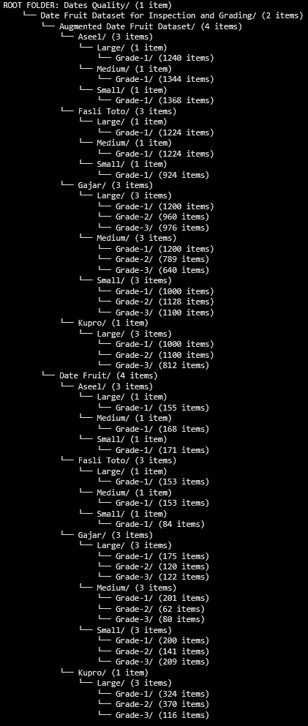
Figure 2: setup and top-level count (tree structure) of original and augmented dataset
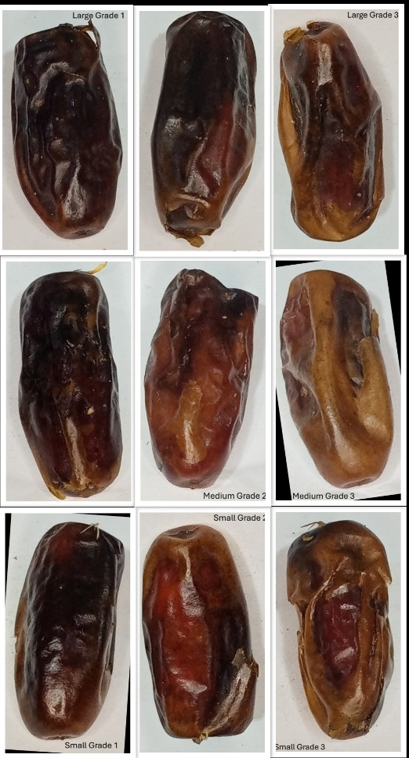
Figure 3: sample of Gajar dates from augmented dataset

3.2 Controlled Variables
Upon selecting this dataset, some details had to be determined before embarking upon training.

3.2.1 Model Selection Rationale
The task involves classifying date images into Grade 1, Grade 2, and Grade 3, where differences between classes are minimal, often manifesting as faint wrinkles, minute discolorations, or slight size variations. This represents a classic fine-grained visual classification (FGVC) challenge, where intra-class variations are small and inter-class differences are subtle.
The following factors influenced the model selection:
- Dataset Characteristics: the dataset used consists of approximately 9,000 colour images. Each image was captured under consistent conditions at a distance of 25 cm, with typical dimensions ranging between 700 - 800 pixels in height and 300 - 400 pixels in width.
- Available Compute: The available computational resources include a T4 GPU with 12 GB of VRAM and a runtime window of about four and a half hours per session, a v5e-1 TPU with 45 GB of RAM but shorter runtime (approximately one hour and forty minutes), and a CPU option which is deemed insufficient for training deep models efficiently. Considering these constraints and objectives, the primary goal is to achieve the highest possible classification accuracy within the available computational budget, while also maintaining feasibility for future mobile deployment.
Although the T4 GPU provides a reasonable environment for fine-tuning, it restricts the use of very large models such as Vision Transformers or large hybrid networks, which are often computationally demanding.

- Augmentation: extensive data augmentation is required to ensure generalisation, as the current dataset is limited to rotation-based augmentations. Additional transformations such as brightness and contrast adjustments, colour jitter, and slight cropping can help the model handle lighting and orientation variability typical of real-world mobile captures.

- Transfer Learning: Given the dataset size, transfer learning is the most appropriate approach. Training a modern convolutional or transformer-based model entirely from scratch would require hundreds of thousands of images and extensive computational resources to prevent overfitting. Transfer learning enables leveraging pretrained models that have already learned rich feature representations from large-scale datasets. Fine-tuning such a model allows faster convergence and improved accuracy with significantly fewer images.

- Framework: since the final system is intended for mobile deployment, models that are both accurate and efficient to deploy using PyTorch were used. The dynamic graph and Pythonic design allow for high levels of customization and flexibility in designing and implementing custom neural network architectures and algorithms. This is why PyTorch is a popular choice in academic research.

3.2.2 Candidate Models and Comparative Evaluation
Several architectures were considered during the selection process, including EfficientNet (B0–B4 and V2 variants), ConvNeXt (Tiny and Small), Swin Transformers, DeiT (Data-Efficient Image Transformers), and MobileNetV3. Each was evaluated based on multiple criteria, including accuracy potential, availability of FGVC-pretrained weights, compatibility with TensorFlow, training feasibility under T4 GPU constraints, and portability to mobile environments.
Model | Accuracy (FGVC Tasks) | Computational Efficiency | Transfer Learning Support | Suitability for Fine-Grained Classification
EfficientNet-B3 | High (FGVC benchmark-proven) | Excellent (balanced compute and accuracy) | Yes (CUB-200, ImageNet) | Very High
ResNet50 | Moderate to High | Moderate | Yes (ImageNet, FGVC-Aircraft) | High
DenseNet121 | High | Moderate | Yes (ImageNet) | High
MobileNetV3 | Moderate | Very High (lightweight) | Yes (ImageNet) | Medium
Swin Transformer | Very High | Low (compute-intensive) | Yes (FGVC and COCO) | Very High but impractical
Table 1: Comparison of Candidate Architectures for Fine-Grained Date Grading
Among these, EfficientNet-B3 emerged as the most suitable candidate. It strikes an effective balance between model capacity and computational efficiency, possessing roughly 12 million parameters while maintaining strong transfer learning performance.
Pretrained EfficientNet-B3 models trained on FGVC datasets such as CUB-200 are publicly available, providing an ideal starting point for the fine-grained nature of the date grading problem. In comparison, transformer-based models like Swin-Tiny or DeiT-Tiny may offer slightly higher potential accuracy, but at a substantial cost in memory usage and training time, often exceeding the practical limits of a T4 GPU. ConvNeXt-Tiny models also deliver competitive accuracy but are primarily available in PyTorch and require additional conversion steps for TensorFlow deployment. MobileNetV3 and EfficientNet-Lite variants, while highly efficient and well-suited for mobile environments, typically achieve lower accuracy in FGVC tasks and are therefore more appropriate for later distillation or deployment stages rather than as the primary model.

3.2.3 General Preprocessing
We decided to train the model on the only date type which had all three grades and all three sizes present, which was the Gajar date. We also decided to use the original dataset because the augmented version only contained rotated images, with no consideration for other augmentation techniques. This is because the authors may not have intended for this dataset to be used for end-user applications, which require higher degrees of generalisation.
We combined the images in the Gajar directory by grade, as in: small, medium and large Grade 1 Gajar dates go into one directory called Grade 1, small, medium and large Grade 2 Gajar dates go into one directory called Grade 2 and small, medium and large Grade 3 Gajar dates go into one directory called Grade 3.
Then we split the dataset into 70/15/15 for training, validation and testing, respectively. This would allow us to manipulate the training data without affecting the capacity for evaluation in validation and testing. We applied aspect ratio-preserving padded resizing on all training images to become 300x300 pixels. EfficientNet-B3 requires images to be of this size.

3.2.4 Training Considerations
The model will be trained using transfer learning, initially freezing the pretrained layers to train a new classification head, followed by gradual unfreezing for fine-tuning. A batch size of 16 is expected to be optimal under mixed-precision training on the T4 GPU. The AdamW optimiser with a learning rate of approximately 1e-4 will be employed, along with learning rate scheduling and early stopping to prevent overfitting.
Given Colab runtime limits, the training process can be resumed across sessions using checkpoint saving. Validation will be conducted using non-augmented images to provide a realistic measure of the model’s performance.

3.2.5 Deployment Considerations
Following successful training and evaluation, the final model will be converted to TensorFlow Lite for integration into a mobile application. TensorFlow Lite supports various optimization techniques, including float16 and int8 quantization, which reduce model size and inference time while maintaining most of the original accuracy. For further optimization, knowledge distillation techniques may be applied to train a smaller model, such as MobileNetV3 or EfficientNet-Lite, using the EfficientNet-B3 model as the teacher. This approach allows deployment on resource-constrained mobile devices without significantly sacrificing accuracy.
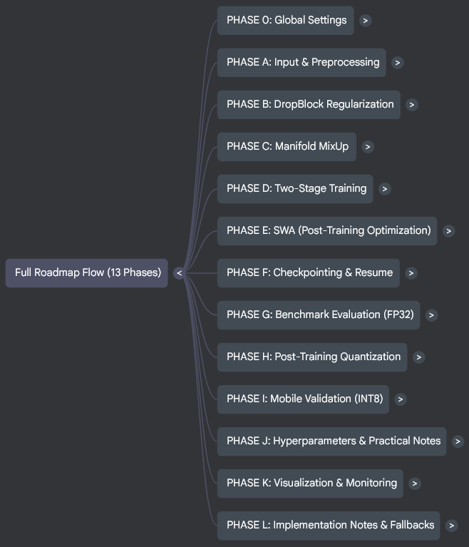
Figure 4: Project roadmap in phases

4. Implementation

4.1 Materials and Methods
The pipeline was developed as a modular PyTorch project within a Google Colab environment, leveraging a T4 GPU.

4.1.1 Dataset and Preprocessing

4.1.1.1 Imbalance Strategy
The training set consisted of 916 images, distributed across the three classes: 403 images in Grade 1, 226 images in Grade 2, 287 images in Grade 3. This distribution presented a notable class imbalance, with Grade 2 being significantly under-represented.
A robust, dual-pronged strategy was implemented to mitigate the negative effects of this imbalance. At the data-loading stage, a WeightedRandomSampler was applied to the training DataLoader. This sampler calculates weights for each class (e.g. for Grade 2) and assigns those weights to each sample. During batch creation, it performs weighted sampling with replacement, effectively oversampling the minority classes (Grade 2, Grade 3) and undersampling the majority class (Grade 1). This ensures that each training batch contains a roughly balanced distribution of all three classes, preventing the model from developing a bias towards the majority class.
As the primary loss function, FocalLoss (with gamma = 2.0) was chosen. While the sampler balances the batches, FocalLoss addresses the problem of example hardness. It modifies the standard cross-entropy loss by down-weighting the contribution of easy, well-classified examples. This forces the model to focus its optimisation efforts on hard, ambiguous examples, precisely, the subtle cases that differentiate the grades. The ‘gamma’ parameter of 2.0 is a standard, effective value for this focusing effect.

4.1.1.2 Preprocessing: Aspect-Ratio Preserving Padding
This was one of the most critical steps. A standard Resize(300, 300) operation would squash or stretch the images, distorting the features (e.g. wrinkle patterns) the model needs to learn. We used albumentations to implement a distortion-free pipeline. A.LongestMaxSize(max_size=300) resizes the image so that its longest edge is 300 pixels, while the other edge is scaled proportionally (e.g. 480×640 225×300). Then, using A.PadIfNeeded(min_height=300, min_width=300, border_mode=cv2.BORDER_REFLECT_101), the image is then padded on the shorter edges to create an image.
This ‘resize-and-pad’ method guarantees that 100% of the original image information is preserved without any geometric distortion. BORDER_REFLECT_101 (reflection padding) was chosen over zero-padding to create a more natural and continuous texture at the image boundaries, preventing the model from learning black bars as a feature.

4.1.1.3 Augmentation Pipeline
The augmentation strategy was designed to be conservative, increasing robustness without destroying fine-grained information.
- A.HorizontalFlip(p=0.5): Standard augmentation for orientation invariance.
- A.Rotate(limit=10, p=0.5, border_mode=cv2.BORDER_REFLECT_101): A conservative rotation was chosen. Aggressive rotations could obscure or distort subtle grade-defining marks.
- A.ColorJitter(p=0.3, ...): Minor adjustments to brightness, contrast, and saturation to simulate varying lighting conditions.
- A.CoarseDropout(max_holes=8, max_height=32, ...): This was the primary pixel-level regularisation.
This is an information dropping technique. By randomly erasing 4-8 small (32 x 32) patches, it forces the model to become robust and learn from the entire fruit image, not just part of it. It prevents the model from cheating by relying on a single, highly salient feature (e.g. one large blemish) to make its classification, thereby encouraging a more holistic feature extraction.

4.1.2 Model Architecture
The backbone of the model is tf_efficientnet_b3.ns_jft_in1k, loaded via the timm library. The EfficientNet architecture provides a balance of accuracy and computational efficiency. The Noisy Student (.ns) weights are critical. They were produced by Google using semi-supervised training on the massive JFT-300M dataset. This results in an exceptionally robust feature extractor that serves as an ideal starting point for transfer learning on a difficult FGVC task. Then, before the global pooling layer, a DropBlock2D layer (with block_size=3 and a scheduled max_drop_prob=0.1) was inserted into the model's head.
Standard Dropout is ineffective on convolutional feature maps because adjacent pixels are highly correlated. DropBlock2D addresses this by dropping contiguous blocks (e.g. 3x3) of the feature map. This provides a much stronger regularisation signal, forcing the network to develop redundant spatial representations and preventing feature co-adaptation. Then we applied ManifoldMixUp feature regularization with alpha=0.2 to approximately 30% of training batches.
Standard MixUp (blending pixels) can create visually nonsensical images that confuse an FGVC model. ManifoldMixUp is a better suited alternative that performs the blending in the latent feature space (i.e. on the 1536-channel feature map from the backbone, before the head). This acts as a powerful abstract regulariser, smoothing the decision boundaries in the feature manifold without creating unrealistic pixel-level artefacts.

4.1.3 Training Methodology
We split the training into two phases:
1. ‘Warmup’ Phase:
A two-stage ‘warmup’ approach was used to stably fine-tune the model.
- Stage 1: Head Training (5 Epochs): The EfficientNet-B3 backbone was frozen, and only the newly initialised head was trained with a high learning rate (HEAD_LR = 1e-2). This allows the classification head to rapidly adapt to the new dataset's features and output distribution without corrupting the powerful, pre-trained backbone weights with large, unstable gradients.
- Stage 2: Full Fine-Tuning (50 Epochs): The entire backbone was unfrozen. The model was trained end-to-end using discriminative learning rates: a high LR for the head (1e-3) and a low LR for the backbone (1e-4). The backbone's weights are already highly optimized. They only need to be nudged gently to adapt to the new task. The newer head, however, requires a higher learning rate to continue its convergence.
2. Post-Training Optimisation – SWA:
After the main training loop was completed, Stochastic Weight Averaging (SWA) was initiated. The model continued training for an additional 5-10 epochs using a fixed, low LR (swa_lr = 1e-5), and the weights from each of these epochs were averaged. This technique finds a wider, flatter minimum in the loss landscape, which is empirically proven to offer better generalisation than any single checkpoint from the training run. The final swa_model.pth is the product of this phase.

4.2 Experimental Setup

4.2.1 Implementation Details
Optimiser: AdamW was chosen over standard Stochastic Gradient Descent (SGD). AdamW offers faster convergence and correctly implements decoupled weight decay (1e-4), which is a key regularisation technique.
Scheduler: we used CosineAnnealingLR with a 3-epoch linear warmup. This strategy provides a smooth, non-reactive decay that is ideal for fine-tuning, allowing the model to settle into a good minimum.
Batching & Gradient Accumulation: we used a physical batch size of 16 (the maximum that fits on the T4's 15GB vRAM) and set the accumulation steps to 4. A physical batch size of 16 is too small for stable training, as it creates noisy batch normalisation statistics. By accumulating gradients over 4 steps, we simulated a much larger Effective Batch Size (EBS) of 64 (16x4), ensuring stable convergence.
Precision: Automatic Mixed Precision (AMP) was enabled via torch.amp.GradScaler to accelerate training and reduce memory usage.

4.2.2 Monitoring and Visualisation
All training runs were logged to Tensorboard for real-time monitoring. Every epoch, the Loss metric was logged during training and validation, and F1-Macro and Per-Class F1 were logged during validation. F1-Macro served as the primary metric for model selection (best_model.pth.tar). Per-Class F1 was essential for monitoring the minority Grade 1 and Grade 2, ensuring FocalLoss and the Sampler were effectively preventing class-based performance collapse.
As for the visuals, the first batch of training data was logged as an image grid to visually confirm the augmentations were conservative and not destroying the images. Also, a validation confusion matrix was logged at every checkpoint to diagnose misclassification patterns (e.g. if the model was consistently confusing Grade 1 and 2). Finally, GRAD-CAM heatmaps for a fixed set of validation images were logged to ensure the model's feature attribution was focused on relevant date features (blemishes, wrinkles) and not on background artefacts.

4.3 Deployment

4.3.1 Model Evaluation
Following the completion of the SWA phase, the final swa_model.pth was loaded into the model skeleton. It was then evaluated one final time on the unseen test set to produce the final, unbiased benchmark metrics. These metrics (Test F1, Accuracy, and Misclassification Cost) were logged to TensorBoard at epoch 999 for clear identification.

4.3.2 Prototype Deployment
The project's final goal was a shareable prototype. The mobile-specific quantization phases originally planned as part of real mobile device deployment were cancelled in favour of a more direct server-side deployment. The Gradio package was chosen for its ability to rapidly create a web UI directly from a Python function. Hugging Face Spaces was chosen as the free, permanent hosting platform.
A new app.py script was created. This script imports the FGVCModel class from model.py, loads the config.yaml to configure the model, loads the trained swa_model.pth weights, and finally defines a predict_grade function that takes a user-uploaded image. The predict_grade function is critical. It applies the exact same deterministic validation transform from dataset.py (LongestMaxSize + PadIfNeeded) to the user's image. This ensures that the data seen by the model at inference time is identically formatted to the data it was validated on, preventing a domain-shift-induced drop in accuracy.

5. Result and Evaluation

5.1 Results
 | Training Results (54 epochs using Early Stopping) | Testing Results (999 epochs)
Loss | 0.5801 | 0.5403
Accuracy | 0.7538 | 0.6784
F1-Score | 0.7109 | 0.6484
Cost | 38 | 67

The validation confusion matrices for the training and testing runs can be compared below.

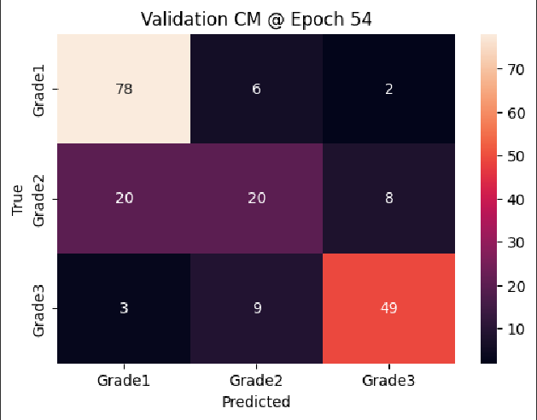
Figure 5: Validation Confusion Matrix after training
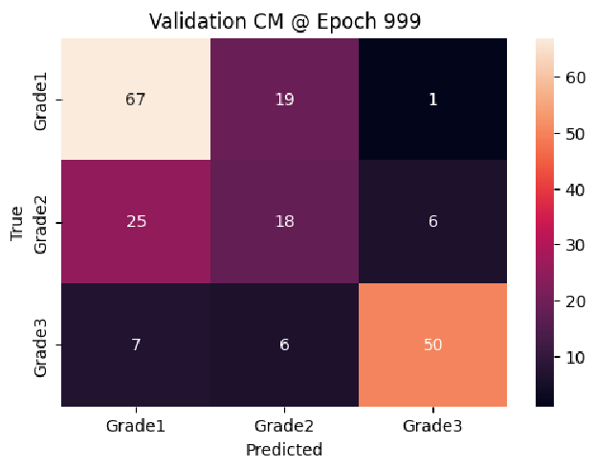
Figure 6: Validation Confusion Matrix after testing
Using GRAD-CAM, we also visually tracked the features that the model focuses on when making predictions.

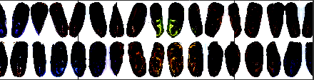
Figure 7: GRAD-CAM heat map for predictions after training run

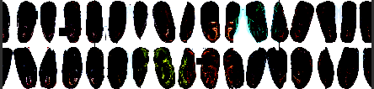
Figure 8: GRAD-CAM heat map for predictions after testing run

5.2 Evaluation

5.2.1 Overfitting
The most prominent observation is the significant drop in accuracy (from 0.7538 to 0.6784) and F1-Score (from 0.7109 to 0.6484) when moving from the training set to the test set. This means that the model performs much better on the data it was trained on than on unseen data (the test set). This is the classic signature of overfitting. The CNN has likely learned the specific details and noise of the training examples rather than the underlying, generalised features needed to accurately grade date fruits in the real world.
Since this is a grading task, the F1-Score (the mean of precision and recall) is a critical metric. The drop here indicates that the model struggles to balance identifying all positive cases (recall) with avoiding false positives (precision) on new, unseen fruits.

5.2.2 Unusual Loss Behaviour
The test loss (0.5403) is slightly lower than the training loss (0.5801), which is an unusual pattern when combined with the large drop in accuracy and F1-score. There are several potential explanations. The distribution of the classes or the difficulty of the samples might be slightly different between the training and test sets. Perhaps the test set contains fewer ‘hard’ samples that result in very high individual losses, or the classes are more balanced, despite the model making more incorrect predictions overall.
It could also be that the loss function might be more forgiving or respond differently to the types of errors the model makes on the test set compared to the training set.
Epoch misalignment may have contributed to this. Training loss is typically reported after the epoch, while test/validation loss is calculated during the early stopping phase. Given the model stopped at 54 epochs, the training loss reported is the loss at that final point.

5.2.3. High Discrepancy in Cost/Time
The ‘Cost’ metric, which is often used for computational or time complexity, is significantly higher for the testing phase (67) than for the training phase (38). This suggests that running the test phase, possibly due to the much larger number of test epochs (999 vs. 54 for training), was significantly more resource-intensive or time-consuming than the actual training up to the point of early stopping.

5.2.4. Effectiveness of Early Stopping
The Early Stopping mechanism successfully halted the training, suggesting that the model had reached a point where performance on a validation set began to degrade or plateau. The subsequent poor performance on the test set confirms that stopping the training was necessary to prevent even more severe overfitting.

6. Conclusion and Future Work
The project demonstrates the feasibility of using machine learning to assess date fruit quality from images alone. The developed model provides a promising foundation for automated quality control in agricultural supply chains, potentially saving time and reducing human error compared to manual inspection.
The evidence is that the model achieved a notable 75.38% training accuracy and a 71.09% F1-Score on the training set. This high performance confirms that the CNN was highly successful at learning the visual features (colour, texture, shape, defects) that distinguish the different quality grades in the training images.
Our experiment aligns with broad research consensus in agricultural computer vision. Numerous studies have successfully used CNNs and deep learning models for classification tasks on fruits in general, like identifying fruit variety, detecting defects, and determining ripeness/quality grade from images, often achieving 90%+ accuracy on dedicated date fruit datasets for simple type classification.
While the experiment proves the potential of the approach, the results on the test set highlight a significant challenge in achieving a robust system ready for the real-world. To improve the model's performance and generalisation, future work should focus on mitigating the overfitting:
- More data/augmentation: increase the size of the training set or use data augmentation techniques (e.g. rotation, flipping, scaling) to make the model more robust to variations in the images. Specifically, also add more date types to compare a model’s performance on.
- Regularization: introduce L1 or L2 regularization or Dropout layers into the CNN architecture to penalise complexity and prevent co-adaptation of neurons.
- Cross-Validation: implement k-fold cross-validation to get a more reliable estimate of the model's performance and ensure the training/validation/test splits are representative.
- Hyperparameter tuning: systematically tune hyperparameters like learning rate and batch size.
- More compute: use better base CNN architectures like VGG-16, or hybrid transformers like Swin.
- Modular approach: it may be better to focus on one aspect at a time – refine quality assessment first, then think about shipping to end-users.
Future work will expand on this by incorporating multimodal inputs such as weight, texture, or X-ray imaging to capture non-visible defects. Additionally, scaling the dataset to include multiple farms and geographic regions could further improve model generalisability. The approach may also be adapted for other agricultural products such as mangoes, figs, or citrus fruits, thereby extending its utility beyond date classification.

There is one crucial aspect that must be mentioned: we chose EfficientNetB3 because we were under the impression that the free compute units provided by Google Colab would diminish quickly. However, we discovered that training only took a few minutes on their T4 GPU. In the future, we will acquire a more varied, bigger dataset, and choose the CNN accordingly; either it would be custom-made, or a bilinear CNN, or an attention-based model, or any suitable model architecture suitable for FGVC.

References
[1] E. T. Bradlow, Y. Hu, and T. H. Ho, “A learning-based model for imputing missing levels in partial conjoint profiles,” Journal of Marketing Research, vol. 41, no. 4, pp. 369–381, 2004, doi: 10.1509/JMKR.41.4.369.47018.
[2] S. Arunachalam, S. C. Bahadir, S. G. Bharadwaj, and R. Guesalaga, “New product introductions for low-income consumers in emerging markets,” J Acad Mark Sci, vol. 48, no. 5, pp. 914–940, Sep. 2020, doi: 10.1007/S11747-019-00648-8.
[3] M. Ferguson and M. E. Ketzenberg, “Information sharing to improve retail product freshness of perishables,” Prod Oper Manag, vol. 15, no. 1, pp. 57–73, 2006, doi: 10.1111/J.1937-5956.2006.TB00003.X.
[4] L. K. Decker et al., “Evaluation of Kansas Beef Consumers’ Awareness and Understanding of Business-to-Consumer Marketing,” Kansas Agricultural Experiment Station Research Reports, vol. 9, no. 1, Jan. 2023, doi: 10.4148/2378-5977.8420.
[5] “Schiffman, L. G., Kanuk, L. L., & Kumar, S. R. (2010). Consumer Behavior (10th ed.). New Delhi Pearson Prentice Hall. - References - Scientific Research Publishing.” Accessed: Sep. 21, 2025. [Online]. Available: https://www.scirp.org/reference/referencespapers?referenceid=2867513
[6] L. D. Ordóñez, L. Benson, and A. Pittarello, “Time-pressure perception and decision making,” The Wiley Blackwell Handbook of Judgment and Decision Making, pp. 519–542, Jan. 2015, doi: 10.1002/9781118468333.CH18.
[7] A. E. Faerber and D. H. Kreling, “Content analysis of false and misleading claims in television advertising for prescription and nonprescription drugs.,” J Gen Intern Med, vol. 29, no. 1, pp. 110–118, 2014, doi: 10.1007/S11606-013-2604-0.
[8] S. Badshah, A. A. Khan, S. Hussain, and B. Khan, “What users really think about the usability of smartphone applications: diversity based empirical investigation,” Multimed Tools Appl, vol. 80, no. 6, pp. 9177–9207, Mar. 2021, doi: 10.1007/S11042-020-10099-X.
[9] X. Zheng, S. Zheng, Y. Kong, and J. Chen, “Recent advances in surface defect inspection of industrial products using deep learning techniques,” International Journal of Advanced Manufacturing Technology, vol. 113, no. 1–2, pp. 35–58, Mar. 2021, doi: 10.1007/S00170-021-06592-8.
[10] S. Sundaram and A. Zeid, “Artificial Intelligence-Based Smart Quality Inspection for Manufacturing,” Micromachines (Basel), vol. 14, no. 3, Mar. 2023, doi: 10.3390/MI14030570.
[11] J. L. Kleen and R. Guatteo, “Precision Livestock Farming: What Does It Contain and What Are the Perspectives?,” Animals, vol. 13, no. 5, Mar. 2023, doi: 10.3390/ANI13050779.
[12] R. Al-Yahyai and A. Manickavasagan, “Quality of dates: Influencing factors and assessment methods,” Acta Hortic, vol. 1012, pp. 1241–1246, Nov. 2013, doi: 10.17660/ACTAHORTIC.2013.1012.167.
[13] Oussama Aiadi and Mohammed Lamine Kherfi, “(PDF) A new method for automatic date fruit classification.” Accessed: Sep. 28, 2025. [Online]. Available: https://www.researchgate.net/publication/320816394_A_new_method_for_automatic_date_fruit_classification
[14] M. Koklu, R. Kursun, Y. S. Taspinar, and I. Cinar, “Classification of Date Fruits into Genetic Varieties Using Image Analysis,” Math Probl Eng, vol. 2021, 2021, doi: 10.1155/2021/4793293.
[15] C. Lin, P. Yang, Q. Wang, Z. Qiu, W. Lv, and Z. Wang, “Efficient and accurate compound scaling for convolutional neural networks,” Neural Networks, vol. 167, pp. 787–797, Oct. 2023, doi: 10.1016/J.NEUNET.2023.08.053.
[16] K. Albarrak, Y. Gulzar, Y. Hamid, A. Mehmood, and A. B. Soomro, “A Deep Learning-Based Model for Date Fruit Classification,” Sustainability 2022, Vol. 14, Page 6339, vol. 14, no. 10, p. 6339, May 2022, doi: 10.3390/SU14106339.
[17] A. F. R. Cordeiro, E. Oliveirajr, and Y. M. G. Costa, “Date Fruit classification using a wide range of classifiers,” International Conference on Systems, Signals, and Image Processing, vol. 2023-June, 2023, doi: 10.1109/IWSSIP58668.2023.10180302.
[18] I. Boumaraf, A. Djeffal, S. Setta, and A. Taleb-Ahmed, “Improving Date Fruit Sorting with a Novel Multimodal Approach and CNNs,” International Journal of Advances in Soft Computing and its Applications, vol. 15, no. 3, pp. 190–206, 2023, doi: 10.15849/IJASCA.231130.13.
[19] A. Almutairi, J. Alharbi, S. Alharbi, H. F. Alhasson, S. S. Alharbi, and S. Habib, “Date Fruit Detection and Classification Based on Its Variety Using Deep Learning Technology,” IEEE Access, vol. 12, pp. 190666–190677, 2024, doi: 10.1109/ACCESS.2024.3433485.
[20] Jawad Ali, Muhammad Ramzan, and Abid Rafiq, “DeepPalm: Deep Learning Classification Model for Date Palm Varieties | Journal of Computing & Biomedical Informatics.” Accessed: Sep. 21, 2025. [Online]. Available: https://jcbi.org/index.php/Main/article/view/446
[21] K. Eskaf, “SmartDate: AI-Driven Precision Sorting and Quality Control in Date Fruits,” 2024 IEEE 21st International Conference on Smart Communities: Improving Quality of Life using AI, Robotics and IoT, HONET 2024, pp. 124–129, 2024, doi: 10.1109/HONET63146.2024.10822938.
[22] I. Kourtiche, M. M. O. Bendjima, and M. E. A. Kourtiche, “Date fruit classification using CNN and stacking model,” Indonesian Journal of Electrical Engineering and Computer Science, vol. 39, no. 2, p. 1373, Aug. 2025, doi: 10.11591/IJEECS.V39.I2.PP1373-1383.
[23] J. Yu et al., “In-field grading and sorting technology of apples: A state-of-the-art review,” Comput Electron Agric, vol. 226, Nov. 2024, doi: 10.1016/J.COMPAG.2024.109383.
[24] “(PDF) Real-Time Mango Grading Based on Size Using Machine Vision Technique.” Accessed: Sep. 28, 2025. [Online]. Available: https://www.researchgate.net/publication/395472292_Real-Time_Mango_Grading_Based_on_Size_Using_Machine_Vision_Technique
[25] K. T, V. P, T. B. Azeez, S. K, P. S, and S. P, “An Automatic Mango Quality Grading System in Smart Agriculture using Novel Adaptive Feature Vector and Ensemble Learning,” Multimed Tools Appl, Sep. 2025, doi: 10.1007/S11042-025-20688-3.
[26] G. Guillergan, R. Sabay, D. Madrigal, and J. Bual, “Naive Bayes Classifier in Grading Carabao Mangoes,” Technium: Romanian Journal of Applied Sciences and Technology, vol. 22, pp. 14–32, Apr. 2024, doi: 10.47577/TECHNIUM.V22I.10925.
[27] W. Huang, Y. Wang, Y. Wang, and X. Zhang, “Non-destructive grading technique for mangoes using a flexible impedance sensing system and YOLOv5s_CBAM,” J Food Process Eng, vol. 47, no. 5, May 2024, doi: 10.1111/JFPE.14631.
[28] Aisha Hakami and Muhammad Arif, “(PDF) Automatic Inspection of the External Quality of the Date Fruit.” Accessed: Sep. 28, 2025. [Online]. Available: https://www.researchgate.net/publication/338754334_Automatic_Inspection_of_the_External_Quality_of_the_Date_Fruit
[29] M. Almomen, M. Al-Saeed, and H. F. Ahmad, “Date Fruit Classification Based on Surface Quality Using Convolutional Neural Network Models,” Applied Sciences (Switzerland), vol. 13, no. 13, Jul. 2023, doi: 10.3390/APP13137821.
[30] Y. Noutfia, E. Ropelewska, Z. Jóźwiak, and K. Rutkowski, “Non-Destructive Monitoring of External Quality of Date Palm Fruit (Phoenix dactylifera L.) During Frozen Storage Using Digital Camera and Flatbed Scanner,” Sensors, vol. 24, no. 23, Dec. 2024, doi: 10.3390/S24237560.
[31] M. Cimpoi, S. Maji, and A. Vedaldi, “Deep Filter Banks for Texture Recognition and Segmentation,” 2015. Accessed: Sep. 28, 2025. [Online]. Available: http://www.robots.ox.ac.
[32] L. E. Chuquimarca, B. X. Vintimilla, and S. A. Velastin, “A review of external quality inspection for fruit grading using CNN models,” Artificial Intelligence in Agriculture, vol. 14, pp. 1–20, Dec. 2024, doi: 10.1016/J.AIIA.2024.10.002.
[33] “Date Fruit Classification App · Streamlit.” Accessed: Sep. 21, 2025. [Online]. Available: https://date-fruit-classification.streamlit.app/

